ASSIGNMENT- 1

Use retail_events_db;
select * from dim_campaigns;
select * from dim_products;
select* from dim_Stores;
select * from fact_Events;

-- Q1. Basic Filtering – High-Value Products
-- Find all event records where the base_price is greater than 1,000.

SELECT event_id,store_id,product_code, base_price, promo_type FROM Fact_Events where base_price>1000;
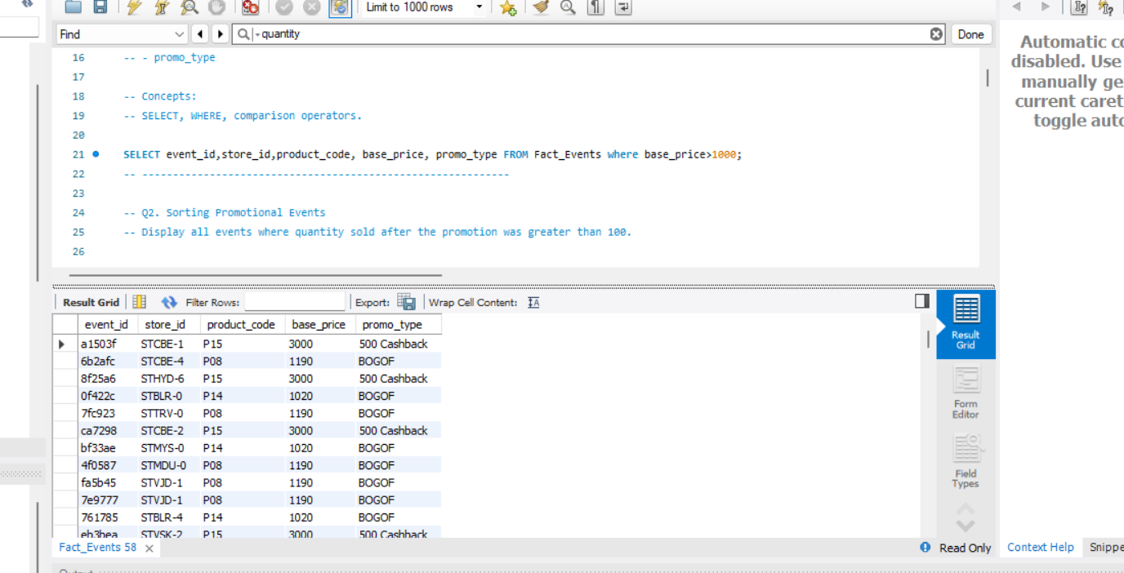

-- Q2. Sorting Promotional Events
-- Display all events where quantity sold after the promotion was greater than 100.

-- Display:
-- - event_id
-- - product_code
-- - promo_type
-- - quantity_sold(before_promo)
-- - quantity_sold(after_promo)

-- Sort by quantity_sold(after_promo) in descending order.

-- Concepts:
-- WHERE, ORDER BY, DESC.
SELECT event_id, product_code, promo_type,`quantity_sold(before_promo)`,`quantity_sold(after_promo)` FROM fact_events
WHERE `quantity_sold(after_promo)` >100
ORDER BY `quantity_sold(after_promo)` DESC;
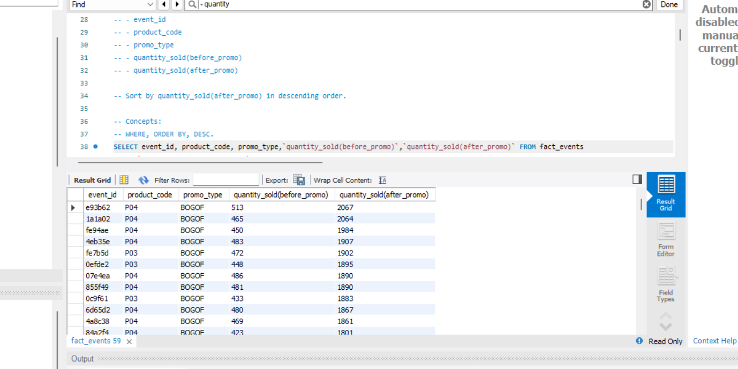

-- Q3. DISTINCT Promotion Types
-- Find all unique promotion types used in the dataset.

-- Display only the unique promo_type values.

-- Concepts:
-- DISTINCT.
SELECT DISTINCT promo_type FROM fact_events;
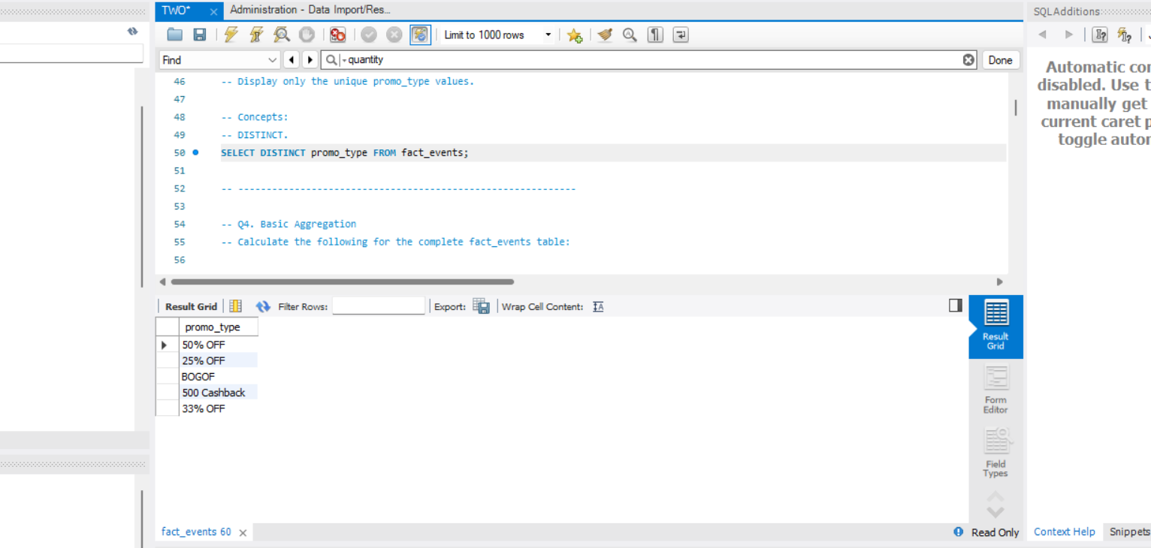

-- Q4. Basic Aggregation
-- Calculate the following for the complete fact_events table:

-- - Total number of events
-- - Total quantity sold before promotion
-- - Total quantity sold after promotion
-- - Average base price
-- - Maximum base price
-- - Minimum base price

-- Return all metrics in one row.

-- Concepts:
-- COUNT, SUM, AVG, MAX, MIN.

SELECT COUNT(*) AS `Total number of events`,
SUM(`quantity_sold(before_promo)`) AS `Total quantity sold before promotion`,
SUM(`quantity_sold(after_promo)`)AS `Total quantity sold after promotion`,
AVG(base_price) AS`Average base price`,
MAX(base_price)AS `Maximum base price`,
MIN(base_price)AS `Minimum base price`
from fact_events;
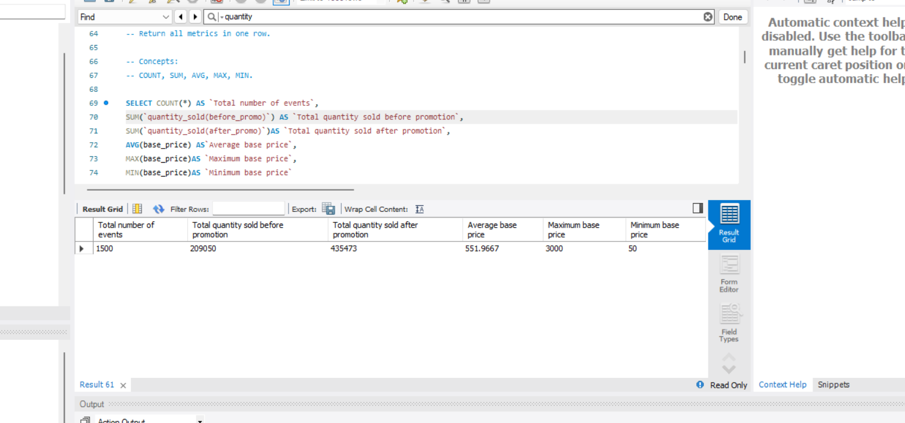

-- ============================================================
-- MEDIUM QUESTIONS
-- ============================================================

-- Q5. Sales Volume by Promotion Type

SELECT Promo_type,
Count(*) AS `Number of events`,
SUM(`quantity_sold(before_promo)`) AS `Total quantity sold before promotion`,
SUM(`quantity_sold(after_promo)`)AS `Total quantity sold after promotion`
FROM fact_events
GROUP BY promo_type
ORDER BY `Total quantity sold after promotion` DESC;

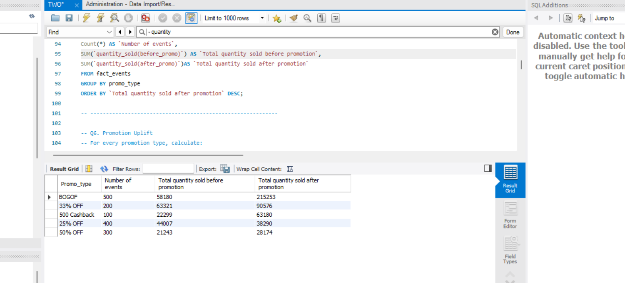

-- Q6. Promotion Uplift

SELECT
promo_type,
SUM(`quantity_sold(before_promo)`) AS `total_before`,
SUM(`quantity_sold(after_promo)`)AS `total_after`,
SUM(`quantity_sold(after_promo)`)-SUM(`quantity_sold(before_promo)`) AS `quantity_change`
FROM fact_events
GROUP BY promo_type
ORDER BY `quantity_change` DESC;

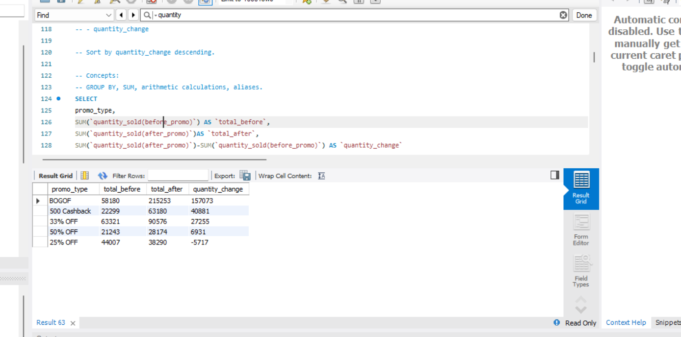

-- Q7. Product Performance
SELECT f.product_code,
product_name,
category,
SUM(`quantity_sold(after_promo)`)AS `total quantity after promotion`
FROM fact_events f
JOIN dim_products d ON f.product_code = d.product_code
GROUP BY f.product_code, d.product_name, d.category
ORDER BY `total quantity after promotion` DESC;

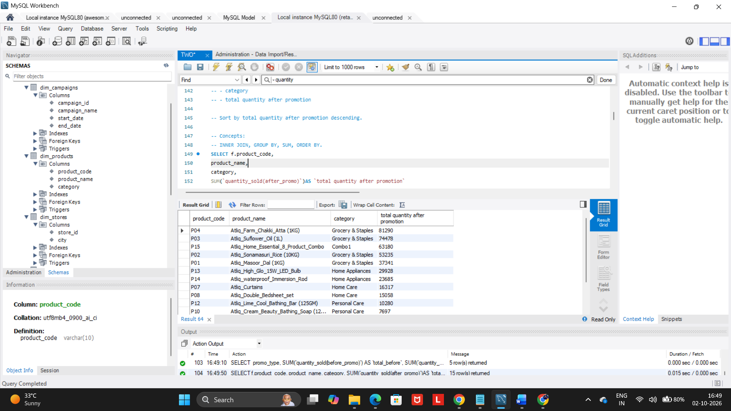

-- Q8. Category-Level Performance

SELECT
d.category,
Count(*) AS `Number of events`,
SUM(`quantity_sold(before_promo)`) AS `Total quantity sold before promotion`,
SUM(`quantity_sold(after_promo)`)AS `Total quantity sold after promotion`,
SUM(`quantity_sold(after_promo)`)-SUM(`quantity_sold(before_promo)`) AS `quantity_change`
FROM fact_events f
JOIN dim_products d ON f.product_code = d.product_code
GROUP BY category
ORDER BY `Total quantity sold after promotion` DESC;

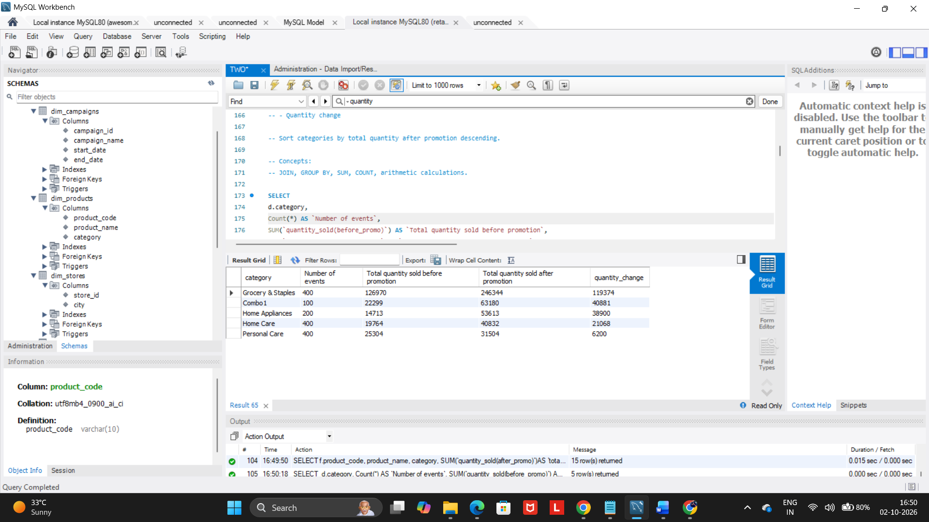

-- Q9. Store Performance
SELECT
city,
COUNT(event_id) AS `event_count`,
SUM(`quantity_sold(before_promo)`) AS `total_before`,
SUM(`quantity_sold(after_promo)`)AS `total_after`
FROM fact_events f
JOIN dim_stores as d ON f.store_id= d.store_id
GROUP BY city
ORDER BY `total_after` DESC;
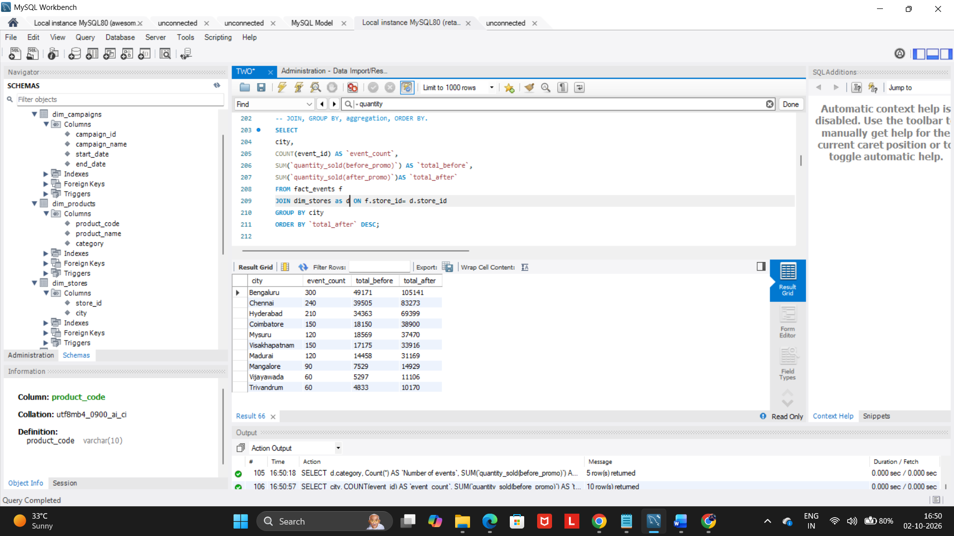

-- Q10. Campaign Performance
SELECT campaign_name,
start_date AS `Start date`,
end_Date AS `End date`,
COUNT(event_id) AS `Number of events`,
SUM(`quantity_sold(before_promo)`) AS `Total quantity sold before promotion`,
SUM(`quantity_sold(after_promo)`)AS `Total quantity sold after promotion`
FROM dim_campaigns d
JOIN fact_events f ON f.campaign_id= d.campaign_id
GROUP BY d.campaign_id, d.campaign_name, d.start_date, d.end_date
ORDER BY `Total quantity sold after promotion` DESC;
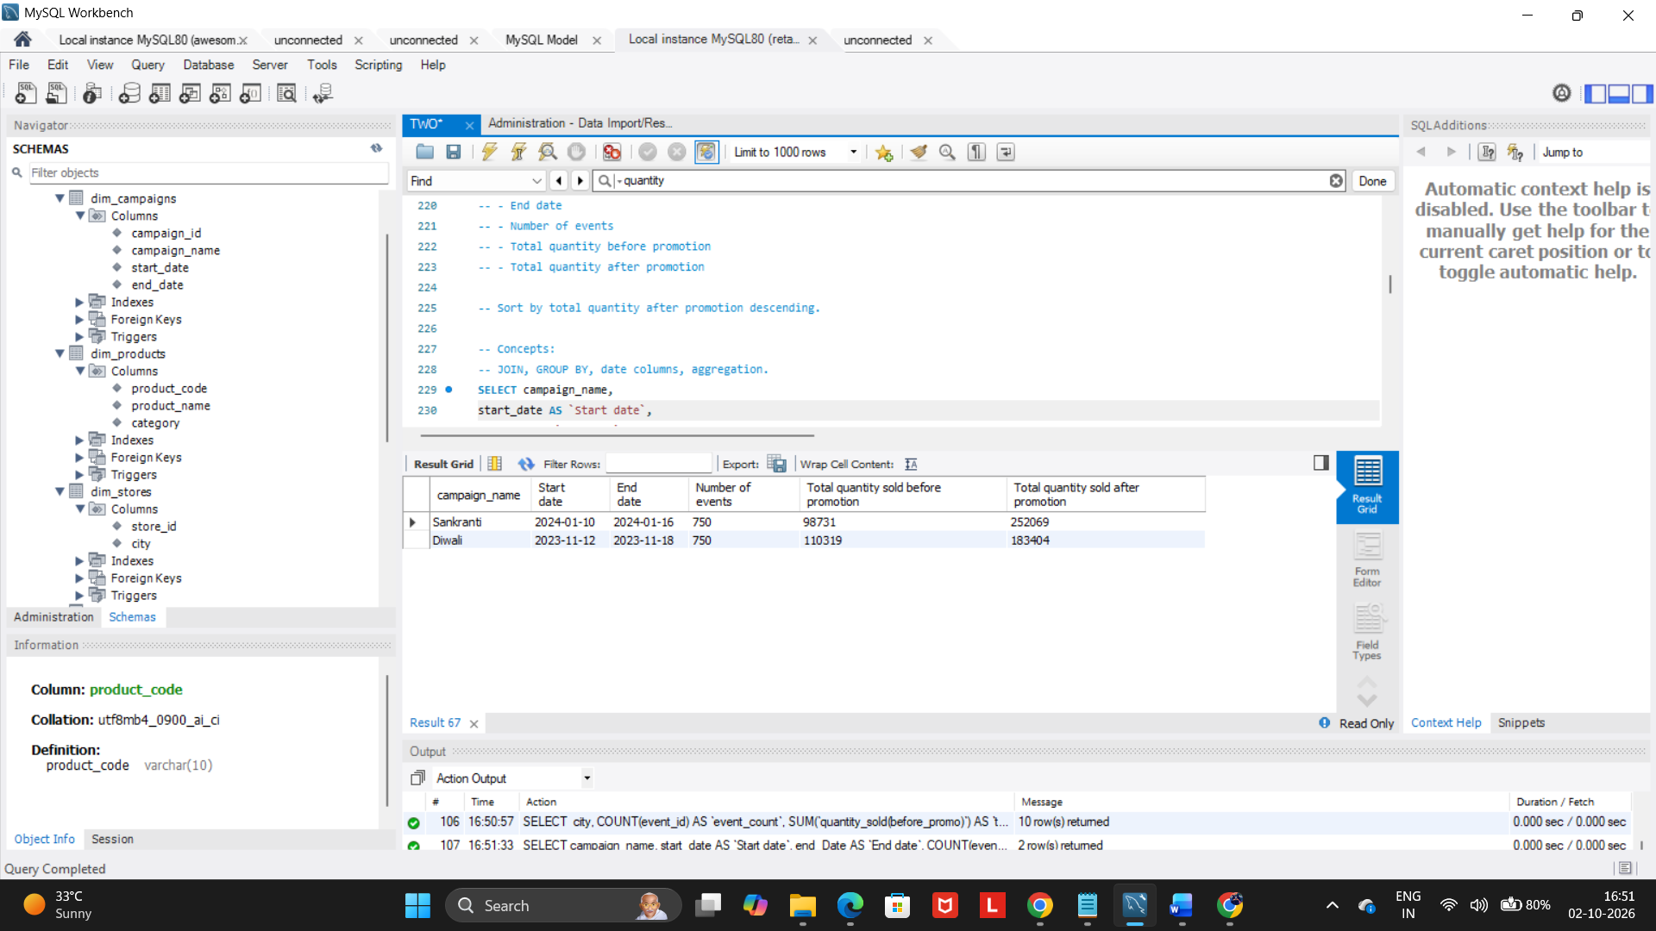

-- Q11. Product Category with HAVING

SELECT category,
SUM(`quantity_sold(after_promo)`)AS `Total quantity sold after promotion`,
AVG(base_price) AS `average base price`
FROM fact_events f
JOIN dim_products d on d.product_code= f.product_code
GROUP BY category
HAVING `Total quantity sold after promotion`>1000
ORDER BY `Total quantity sold after promotion` DESC;
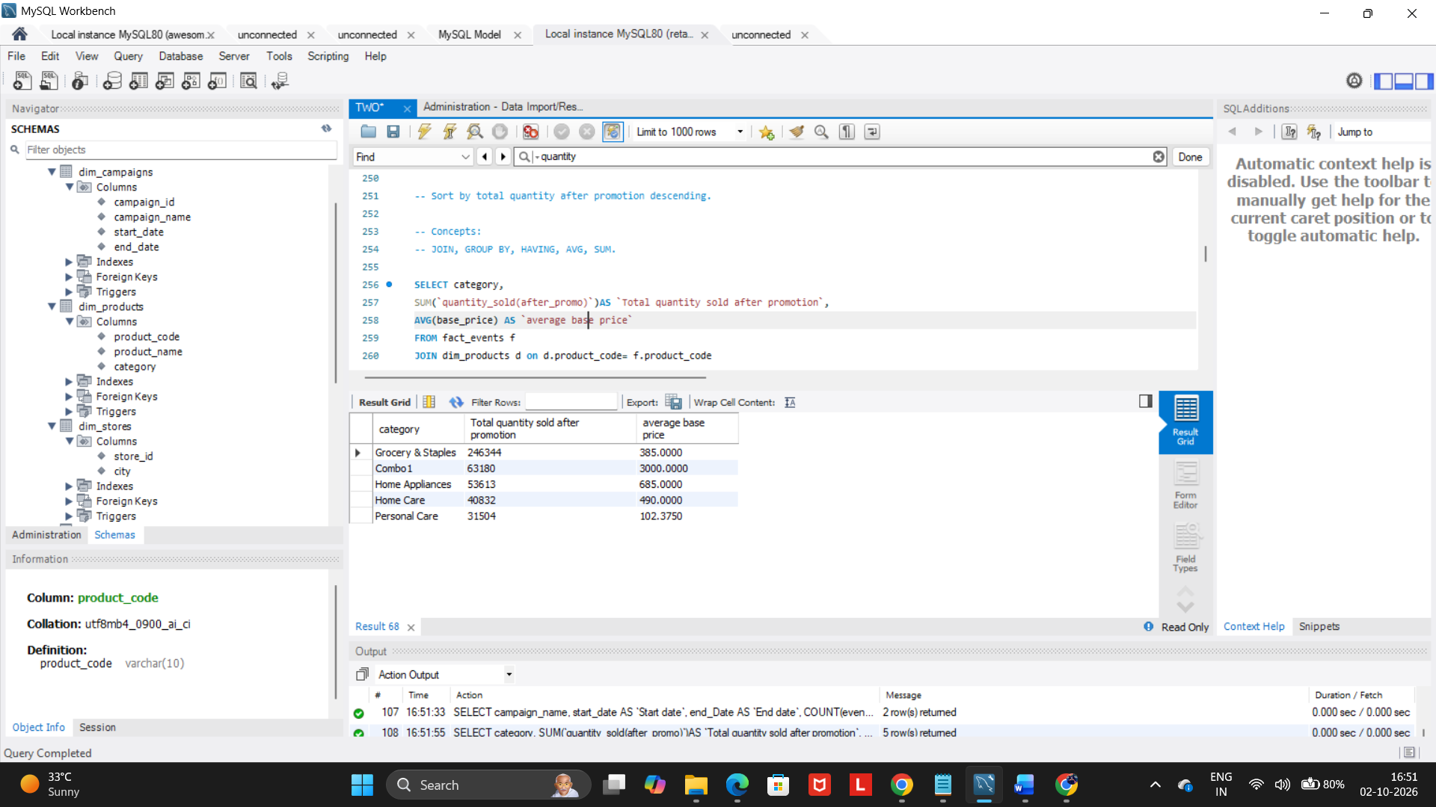

-- Q12. Store + Category Analysis

SELECT city,
category,
SUM(`quantity_sold(after_promo)`)AS `Total quantity sold after promotion`
FROM fact_events f
JOIN dim_products dp ON dp.product_code= f.product_code
JOIN dim_stores ds ON ds.store_id= f.store_id
GROUP BY city, category
ORDER BY city ASC, `Total quantity sold after promotion` DESC;

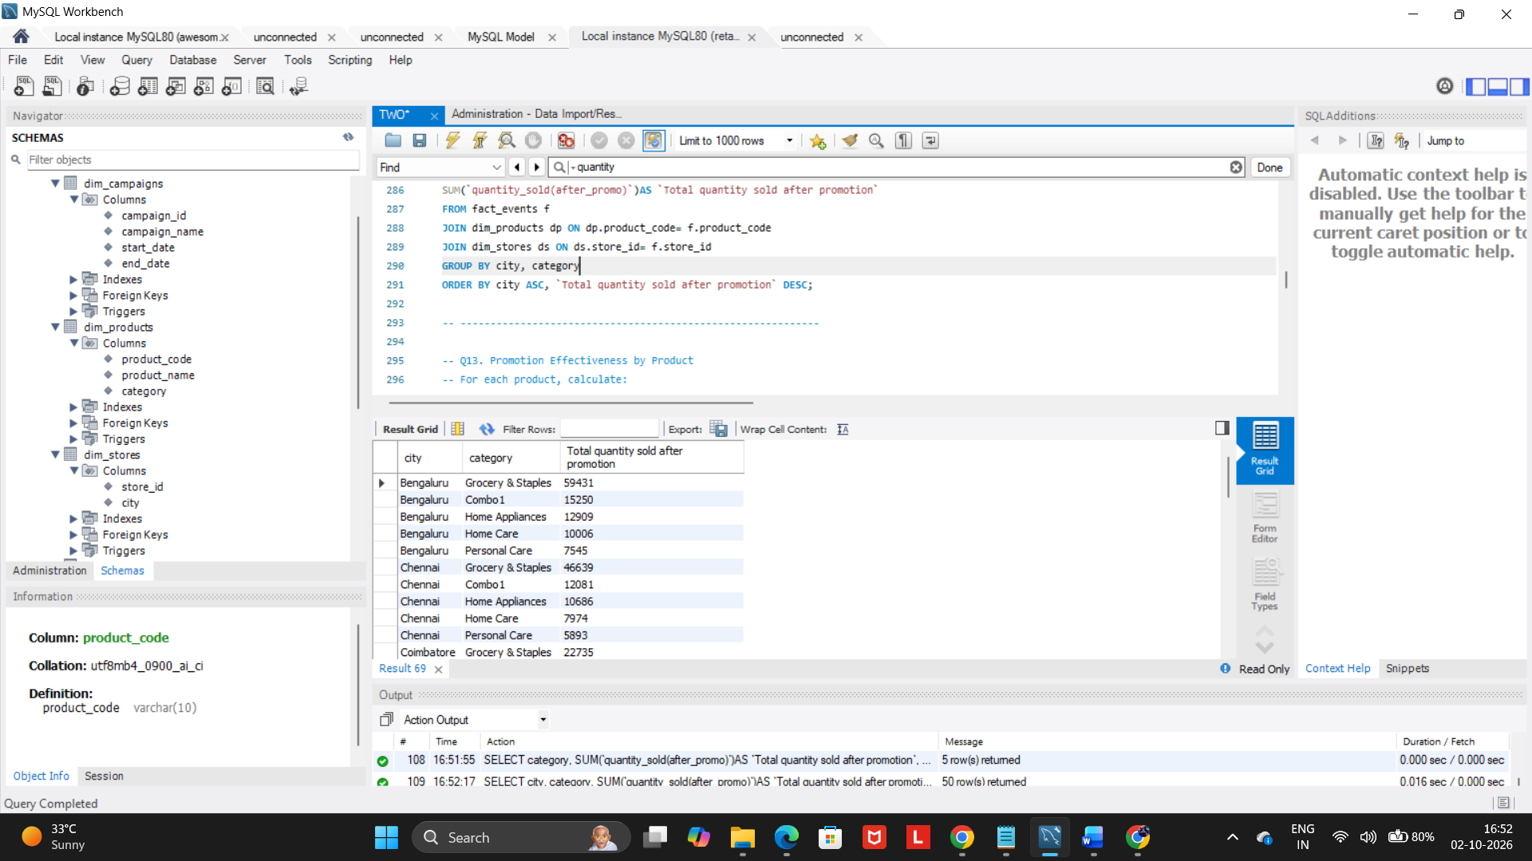

-- Q13. Promotion Effectiveness by Product
SELECT d.product_name,
d.category,
SUM(`quantity_sold(before_promo)`) AS `Total quantity sold before promotion`,
SUM(`quantity_sold(after_promo)`)AS `Total quantity sold after promotion`,
SUM(`quantity_sold(after_promo)`)-SUM(`quantity_sold(before_promo)`) AS `quantity_change`,
((SUM(`quantity_sold(after_promo)`) - SUM(`quantity_sold(before_promo)`)) / NULLIF(SUM(`quantity_sold(before_promo)`), 0)) * 100 AS `Percentage Change`
FROM fact_events f
JOIN dim_products d ON d.product_code = f.product_code
GROUP BY d.product_name, d.category
ORDER BY `Percentage Change` DESC;

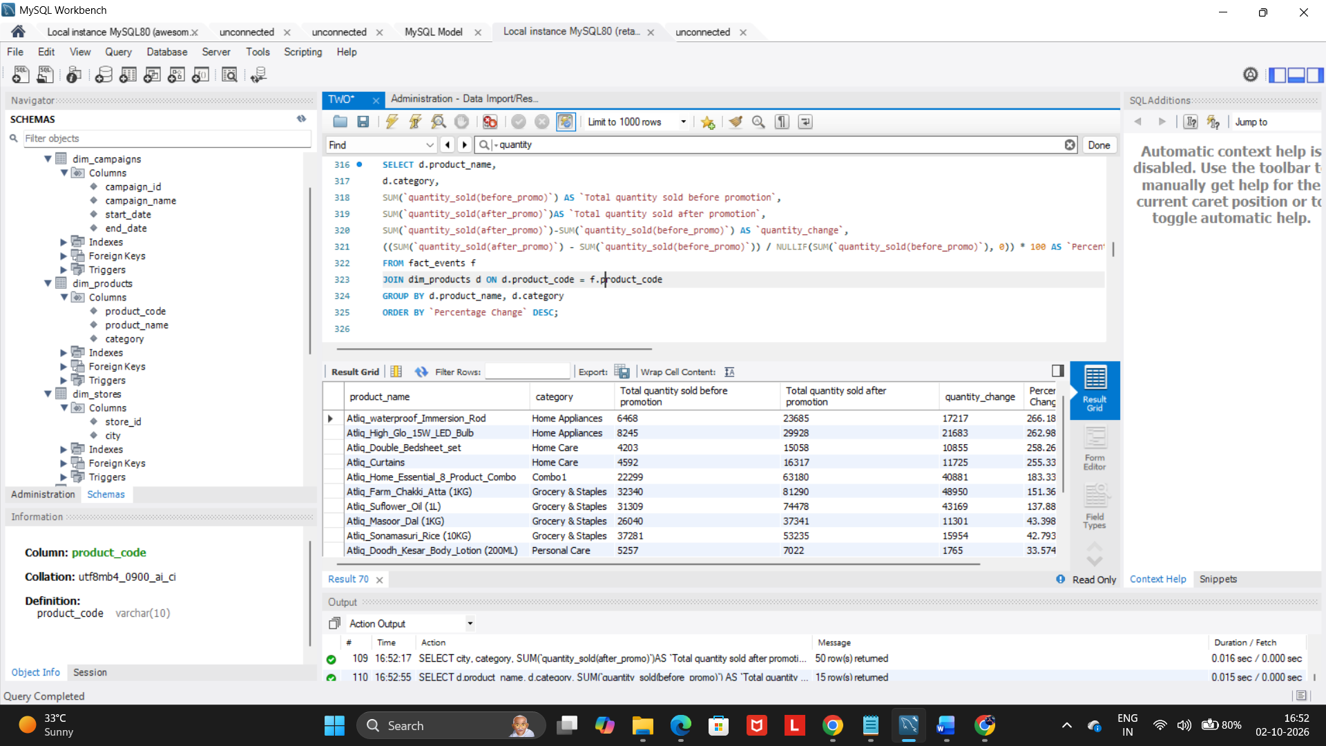

-- ------------------------------------------------------------

-- Q14. Campaign and Promotion Type Analysis
SELECT campaign_name,
promo_type,
count(*) AS event_count,
SUM(`quantity_sold(before_promo)`) AS `total_before`,
SUM(`quantity_sold(after_promo)`)AS total_after,
SUM(`quantity_sold(after_promo)`)-SUM(`quantity_sold(before_promo)`) AS quantity_change
from dim_campaigns dm
JOIN fact_events f ON dm.campaign_id= f.campaign_id
GROUP BY campaign_name, promo_type
ORDER BY campaign_name , quantity_change DESC;

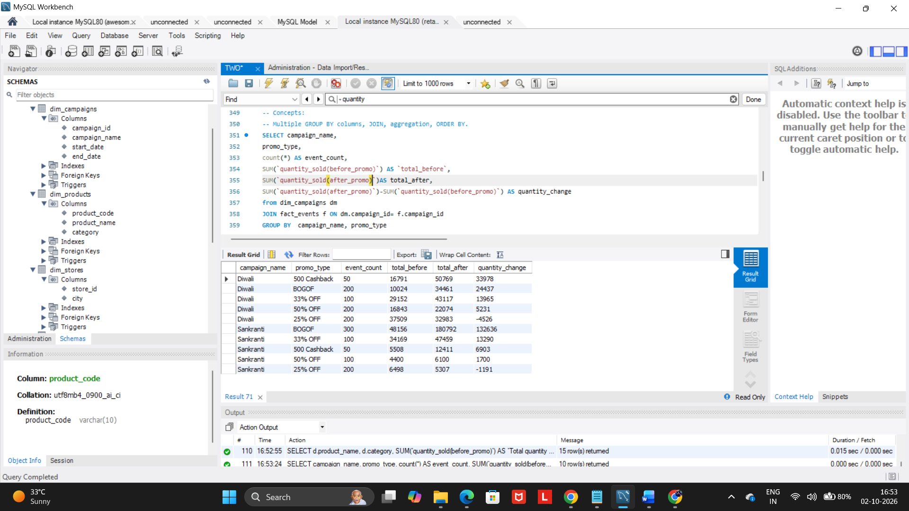

-- Q15. Product Revenue Before and After Promotion
SELECT product_name,
category,
SUM(base_price * `quantity_sold(before_promo)` )AS `Revenue before promotion`,
SUM(base_price * `quantity_sold(after_promo)`) AS `Revenue after promotion`,
SUM(base_price * `quantity_sold(after_promo)`)- SUM(base_price * `quantity_sold(before_promo)` ) AS `Revenue difference`
FROM dim_products dp
JOIN fact_events f ON dp.product_code = f.product_code
GROUP BY dp.product_name, dp.category
ORDER BY `Revenue difference` DESC;

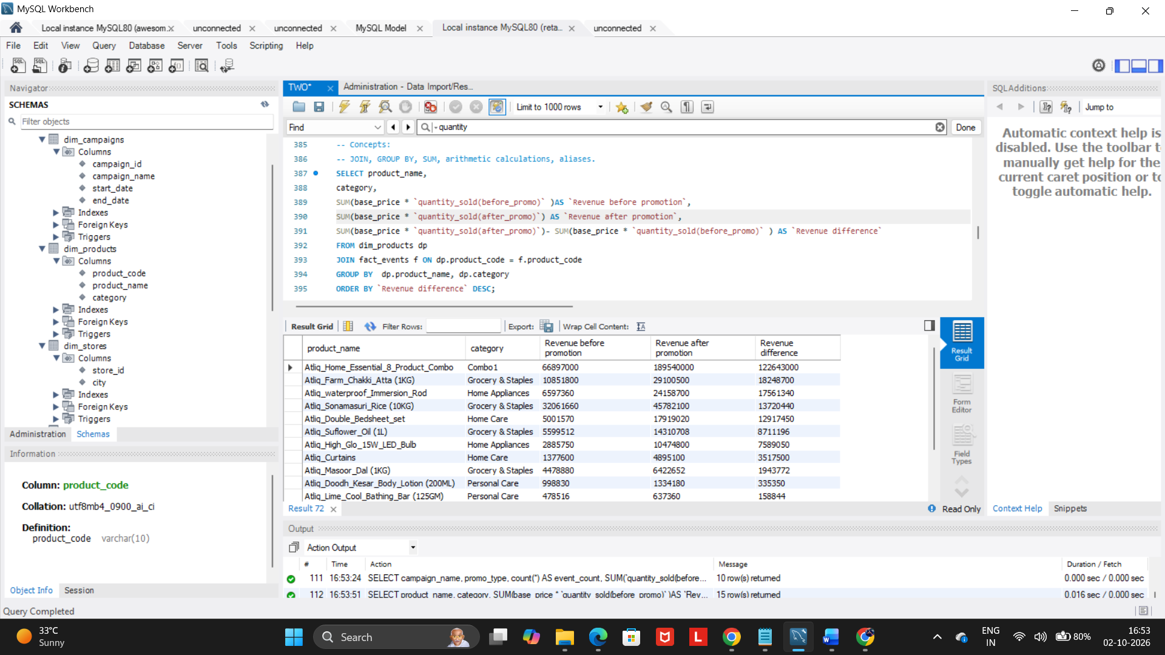

-- Q16. Classify Promotion Performance
SELECT
promo_type,
SUM(`quantity_sold(before_promo)`) AS total_before,
SUM(`quantity_sold(after_promo)`)AS total_after,
((SUM(`quantity_sold(after_promo)`) - SUM(`quantity_sold(before_promo)`)) /
NULLIF(SUM(`quantity_sold(before_promo)`), 0)) * 100 AS percentage_change,
CASE WHEN ((SUM(`quantity_sold(after_promo)`) - SUM(`quantity_sold(before_promo)`)) /
NULLIF(SUM(`quantity_sold(before_promo)`), 0)) * 100 >= 50 THEN "High Impact"
WHEN ((SUM(`quantity_sold(after_promo)`) - SUM(`quantity_sold(before_promo)`)) /
NULLIF(SUM(`quantity_sold(before_promo)`), 0)) * 100 >= 20 THEN "Medium Impact"
ELSE "Low Impact"
END AS performance_category
FROM FACT_EVENTS
GROUP BY promo_type
ORDER BY percentage_change DESC;

-- ============================================================
-- HARD QUESTIONS
-- ============================================================

-- Q17. Top Products Within Each Category
WITH product_info AS(
SELECT d.category,
d.product_name,
SUM(f.`quantity_sold(after_promo)`) AS total_quantity_after,
DENSE_RANK() OVER (
PARTITION BY category
ORDER BY SUM(`quantity_sold(after_promo)`) DESC
) AS category_rank
FROM fact_events f
JOIN dim_products d ON f.product_code = d.product_code
GROUP BY d.category, d.product_name
)
SELECT category, product_name,
total_quantity_after, category_rank
FROM product_info
WHERE category_rank <= 2;
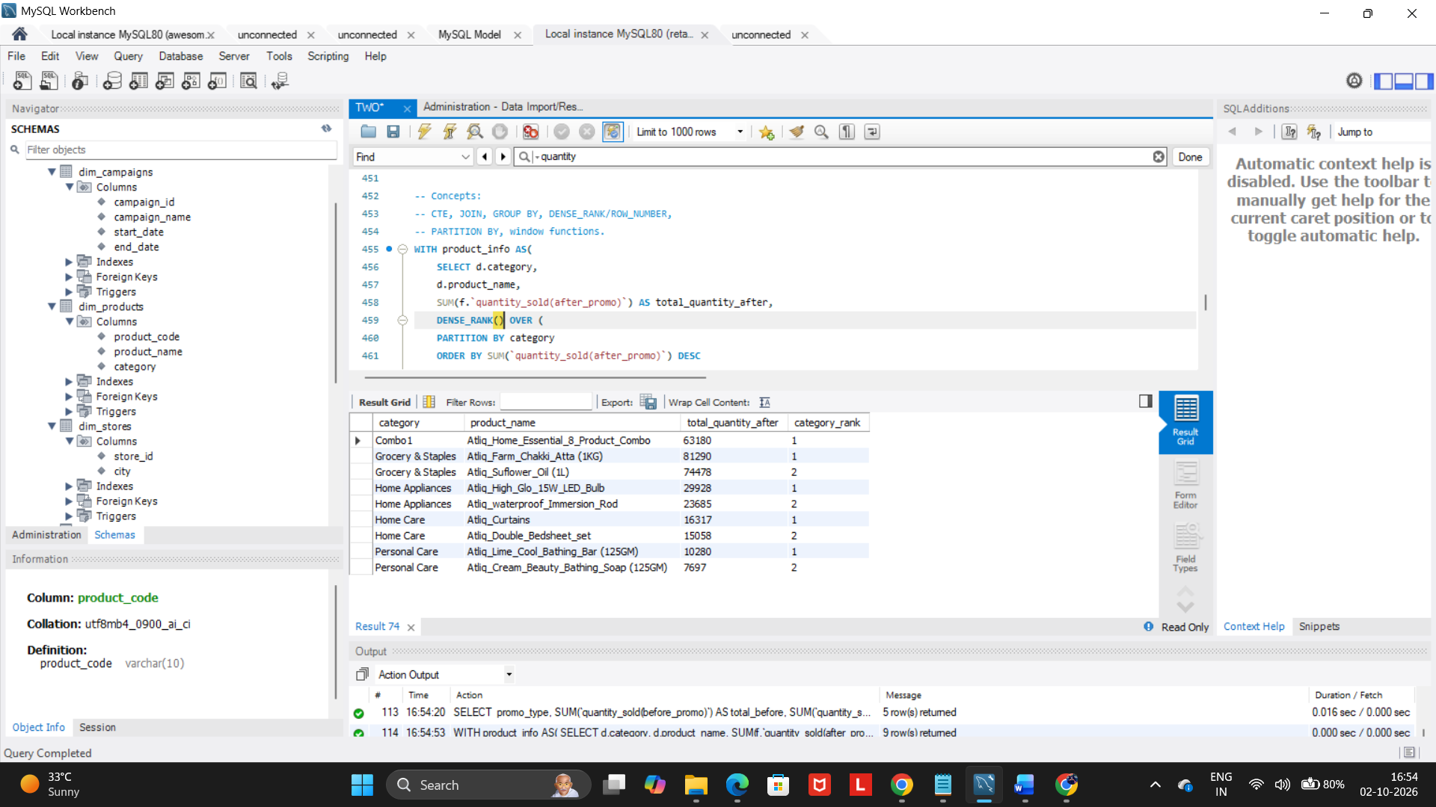

-- Q18. Best-Performing Stores Within Each City
WITH product_info as(
SELECT dm.city,dm.store_id,
SUM(f.`quantity_sold(after_promo)`) AS total_quantity_after,
DENSE_RANK() OVER(
PARTITION BY dm.city
ORDER BY SUM(f.`quantity_sold(after_promo)`) DESC
) AS city_rank
FROM fact_events f
JOIN dim_stores dm ON dm.store_id= f.store_id
GROUP BY dm.city,dm.store_id
)
SELECT city, store_id,
total_quantity_after, city_rank
from product_info
where city_rank<=2;
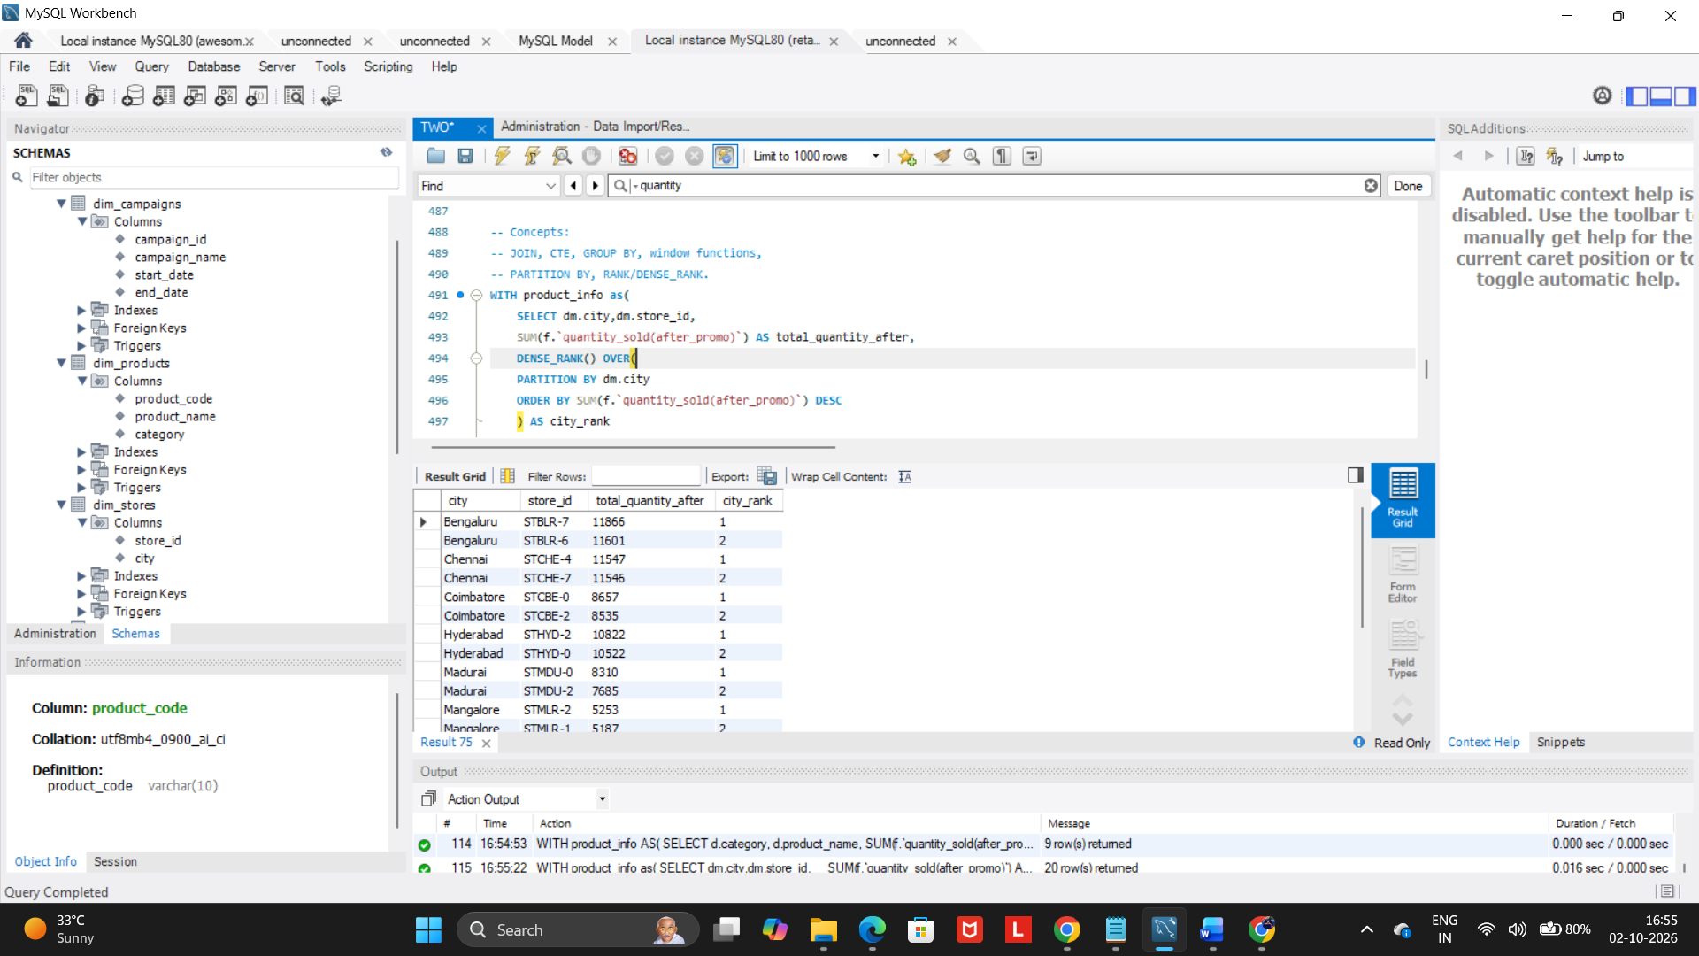

-- Q19. Campaign-Level Product Performance
WITH product_info AS (
SELECT dc.campaign_name,dp.product_name,
SUM(f.`quantity_sold(before_promo)`) AS total_before,
SUM(f.`quantity_sold(after_promo)`)AS total_after,
SUM(f.`quantity_sold(after_promo)`)-SUM(f.`quantity_sold(before_promo)`) AS quantity_change,
((SUM(f.`quantity_sold(after_promo)`) - SUM(f.`quantity_sold(before_promo)`)) /
NULLIF(SUM(f.`quantity_sold(before_promo)`), 0)) * 100 AS percentage_change,
ROW_NUMBER() OVER(
PARTITION BY dc.campaign_name
ORDER BY ((SUM(f.`quantity_sold(after_promo)`) - SUM(f.`quantity_sold(before_promo)`)) /
NULLIF(SUM(f.`quantity_sold(before_promo)`), 0)) * 100 DESC
) AS campaign_rank
FROM fact_events f
JOIN dim_products dp ON dp.product_code= f.product_code
JOIN dim_campaigns dc ON dc.campaign_id= f.campaign_id
GROUP BY dc.campaign_name,dp.product_name
)
SELECT campaign_name, product_name, total_before, total_after,quantity_change,percentage_change,campaign_rank
FROM product_info
where campaign_rank<=3;

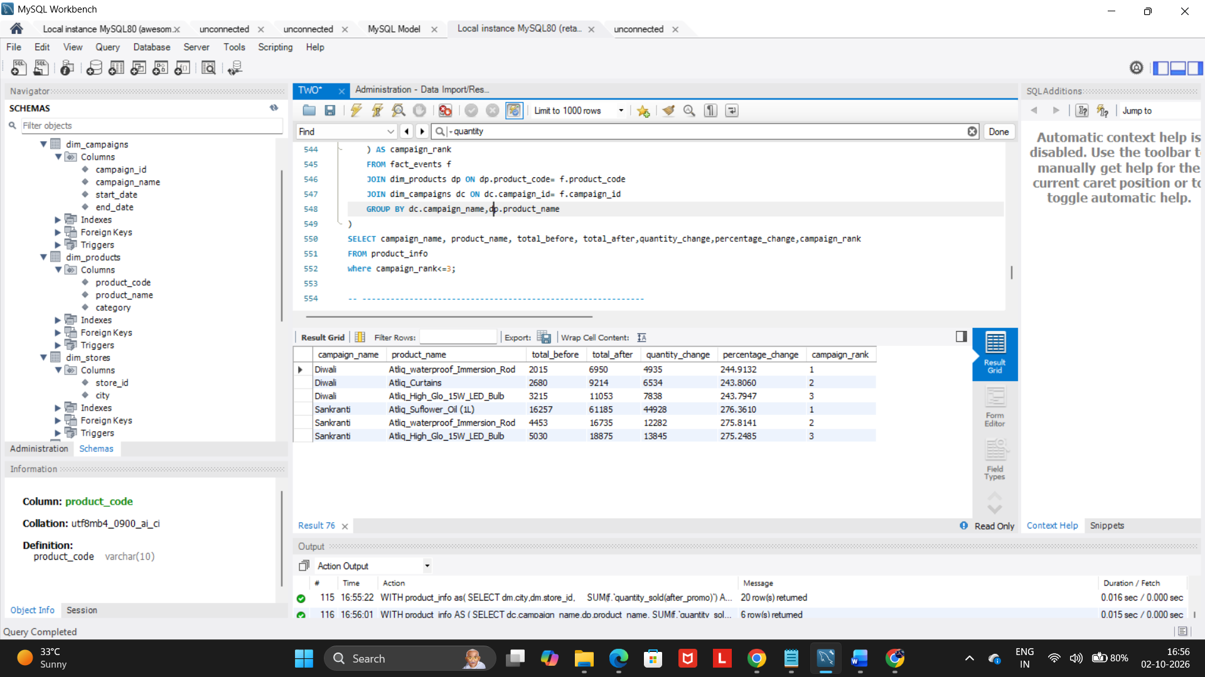

-- Q20. Complete Promotional Performance Analysis
WITH product_info AS(
SELECT dp.product_name AS `Product name`, dp.category,
count(f.event_id) AS `Number of promotional events`,
SUM(f.`quantity_sold(before_promo)`) AS `Total quantity sold before promotion`,
SUM(f.`quantity_sold(after_promo)`)AS `Total quantity sold after promotion`,
SUM(f.`quantity_sold(after_promo)`)-SUM(f.`quantity_sold(before_promo)`) AS `Quantity Change`,
((SUM(f.`quantity_sold(after_promo)`) - SUM(f.`quantity_sold(before_promo)`)) /
NULLIF(SUM(f.`quantity_sold(before_promo)`), 0)) * 100 AS `Percentage Change`,
SUM(base_price * `quantity_sold(before_promo)` )AS `Revenue before promotion`,
SUM(base_price * `quantity_sold(after_promo)`) AS `Revenue after promotion`,
SUM(base_price * `quantity_sold(after_promo)`)- SUM(base_price * `quantity_sold(before_promo)` ) AS `Revenue change`,
AVG(f.base_price) AS `Average base price`,
dense_rank() OVER(
PARTITION BY Category
ORDER BY SUM(base_price * `quantity_sold(after_promo)`)- SUM(base_price * `quantity_sold(before_promo)`) DESC
) AS `Product rank within its category`
FROM dim_products dp
JOIN fact_events f ON dp.product_code=f.product_code
Group by dp.product_name, dp.category
)
SELECT `Product name`, Category, `Number of promotional events`, `Total quantity sold before promotion`,
`Total quantity sold after promotion`, `Quantity Change`, `Percentage Change`, `Revenue before promotion`,
`Revenue after promotion`, `Revenue change`,`Average base price`, `Product rank within its category`
FROM product_info where `Product rank within its category`<=2;

